RH124

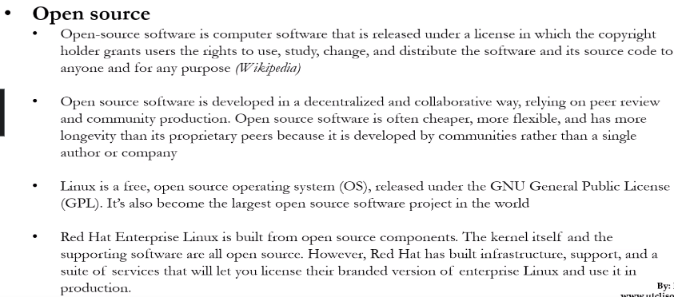



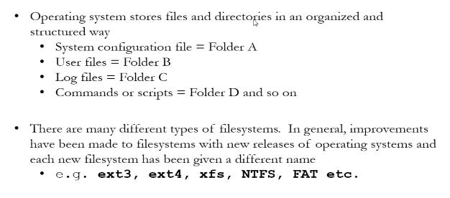

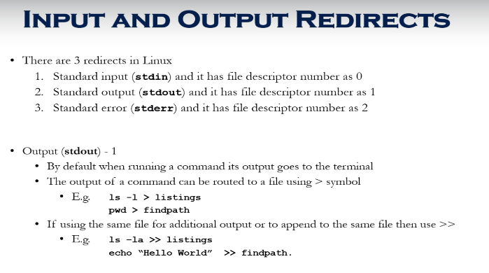

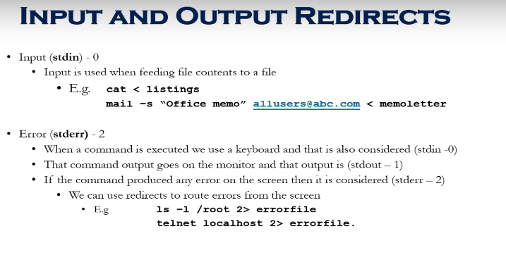

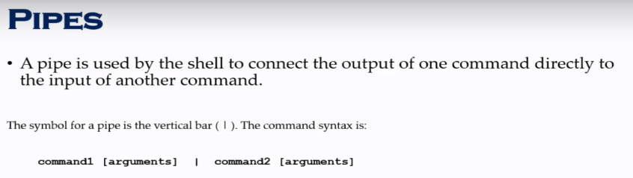

Use pipe with move to show by pages -> space to move to next

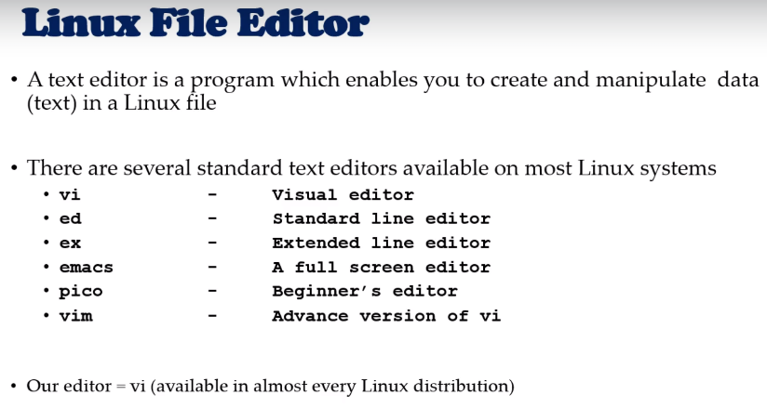

**Commands**

Useradd

Groupadd

Userdel

Groupdel

Usermod

Files when created user

/etc/passwd

/etc/group

/etc/shadow

Useradd -g supergeroes -s /bin/bash -c “descp” -m -d /home/spiderman spiderman

Id spiderman (to check if user created)

Usermod -G superheroes spiderman (changes the group)

Use chrp to change the group also

-d lastday

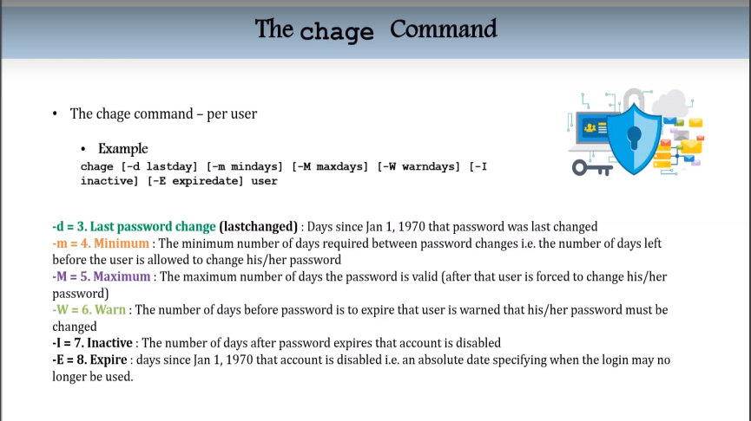

Switch users and sudo access

Su – username

Sudo command

Visudo

File: /etc/sudoers

Usermod -Ga wheel username – adds to group wheel

Proccesses and jobs

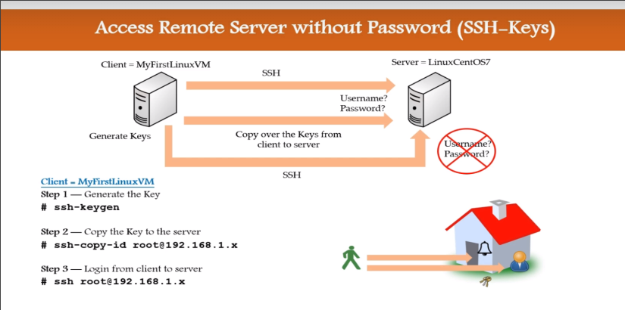

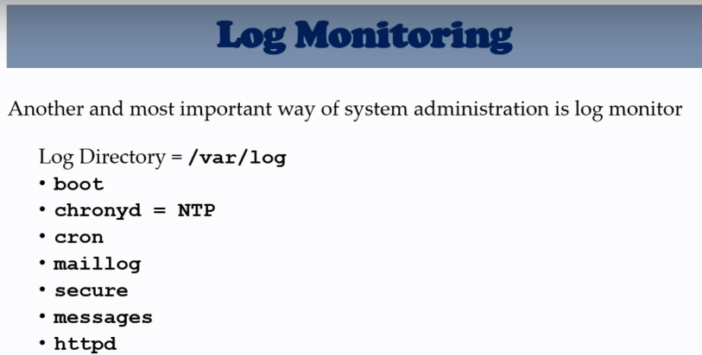

Chronyd – time synchronization

/etc/chronyd.conf

Log file /var/log/chrony

Systemctl start chronyd

Chronyc – program

